
NORTHERN EDUCATION DIVISION
2025 MSCE MOCK EXAMINATION
MATHEMATICS
Subject Number: M132/II.
Wednesday, 2 April. Time Allowed: 2 hour 30 min.
PAPER II 8:00 – 10:30 am. (100 marks)
Question number | Tick if answered | Do not write in these columns
1
2
3
4
5
6
7
8
9
10
11
12
Instructions:
- This paper contains 9 printed pages. Please check.
- Answer all the seven questions in Section A and any four in Section B.
- The maximum number of marks for each answer is indicated against each question.
- Write your answers in the spaces provided on the question paper.
- Scientific calculators may be used.
- All working must be clearly shown.
- Write your name at the top of each page of your question paper in the spaces provided.
- In the table provided on this page, tick against the question number you have answered.

Section A (60 marks)
Answer all the six questions from this section.
- a. Simplify $\frac{n^{2}-4}{{\left(n+2\right)}^{2}} ÷\frac{2-n}{n^{2}+2n}.$ (4 marks)

b. Simplify$\frac{2\sqrt{7}-2\sqrt{45}}{\sqrt{7}-\sqrt{5}}$, giving the answer with a rational denominator. (5 marks)

- a. Solve the equation $\log_{8}{a-2\log_{8}{(\frac{1}{a})}}=2.$ (4 marks)

b. Solve the equation $x^{3}-13x^{2}+47x-35=0.$ (6marks)

- a. The sum of n terms of a G.P is given by $10-$ $\frac{10}{2^{n}}$ , find the first two terms of the progression. (4 marks)

b. The probability that the team trains on Friday is $\frac{2}{5}$. When the team trains, the probability that it will win the match on Saturday is $\frac{5}{7}$ and when it does not train the probability that the team will win the match is $\frac{1}{5}.$ Calculate the probability that the team will win the match. (6 marks)

- a. A father is four times as old as his son. Three years ago, the product of their ages was 259. How old are they now? (5 marks)

b. Using a ruler and a pair of compasses only, construct in the same diagram:
- A circle, centre O with radius 2.4 cm.
- A point R outside the circle, 6.7 cm from O.
- Two tangents to the circle at X and Y.
Measure and state the size of angle XRY. (5 marks)

- a. A bus travels 8km/h on a bearing of 320⁰ from the depot. It then travels 7km/h on a bearing of 020⁰. How far is the bus from the depot after two hours? (5 marks)

- The cost (C) of digging a pit partly varies inversely as the number (n) of laborers and partly as the square of the number of laborers. It costs K12000 for one laborer and K20000 for two laborers. Find the cost of five laborers. (6 marks)

- a. Prove that the angle formed between the chord and the tangent equals the angle subtended by the same chord in alternate segment. (4 marks)

b. Figure 1 shows a prism of length 12cm. The ends are equilateral triangles of sides 10cm. The point N is the midpoint of FC.
A
D

E B
C
N
12 cm
F 10 cm
Figure 1.
Calculate the angle between the line EB and the plane CDEF to two decimal places. (6 marks)

Section B (40 marks)
Answer any four questions from this section.

- Solve the equation: $2^{2a+3}-2^{a+3}-2^{a}+1=0.$ (10 marks)

- Solve the simultaneous equations: $4x^{2}-xy-y^{2}=9$, $2x-y=3.$ (10 marks)

- A news agent with 135 customers sells three papers: Nation, Times and Mail. 70 customers buy Nation, 60 Times and 50 Mail. 17 buy both Nation and Times, 15 buy Times and Mail, and 16 buy Mail and Nation. If $x$ customers buy all three newspapers.
- Illustrate the information in a Venn diagram. (7 marks)

- Find the number of customers who buy all the papers. (3 marks)

- The following are marks scored by some students at a certain Secondary school:
9 12 8 18 3 9 12 12 13 19
22 8 18 14 13 18 7 2 23 14
4 24 14 7 19 12 9 14 17 7
- Using class intervals: 1-5, 6-10, 11-15,……, construct a frequency distribution table. (3 marks)

- Using the frequency distribution table, find the median class. (2 marks)

- Using a scale of 2 cm to represent 5 units on the horizontal axis and 2 cm to represent 2 units on the vertical axis, draw a frequency polygon on the graph paper below. (5 marks)

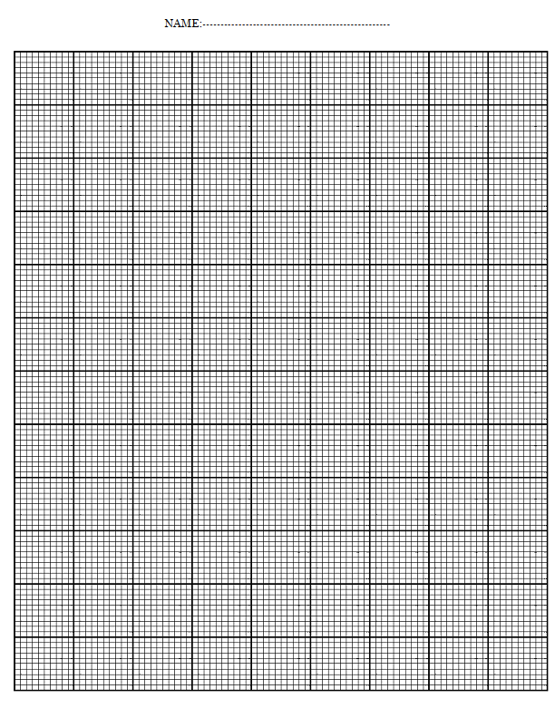
- The table below shows some values of $x$ and $y$ for the equation $y=x^{3}-6x-1.$
$$x$$ | -$3$ | -$2$ | -$1$ | 0 | 1 | 2 | 3
$$y$$ | -10 |  | 4 | -1 | -6 |  | 8

- Complete the table of values. (2 marks)

- Using a scale of 2 cm to represent 1 unit on x-axis and 2 cm to represent 2 units on the y-axis, draw the graph of $y=x^{3}-6x-1$ on the graph paper provided on page 14. (5 marks)

- Use the graph to solve the equation $x^{3}-7x-2=0.$ (3 marks)

12. A teacher gives his students 60 minutes to take a test. The students must answer at least 4 questions from section A, at least 3 from section B, and a total of at least 10 questions from the two sections. It takes 4 minutes for a student to answer each question in section A and 5 minutes to answer each question in section B.
(i) Let $x$ be the number of section A questions and $y$ be the number of section B questions, write four inequalities. (4 marks)

(ii) Illustrate the inequalities graphically using a scale of $2cm$ to represent $2$ units on both axes by shading the unwanted region. (4 marks)

(iii) Using the graphs, find the maximum number of questions from each section the students can answer. (2 marks)

END OF QUESTION PAPER
NB: This paper contains 9 printed pages.

